Use Case Analysis

In this analysis we will focus on the main use cases we have to analys and realize them using UML diagrams like sequence , collaboration and VOPC (View Of Participating Classes) diagrams. We will start with the use case “Booking house”.

1. Booking house

**1.1 Sequence diagram**

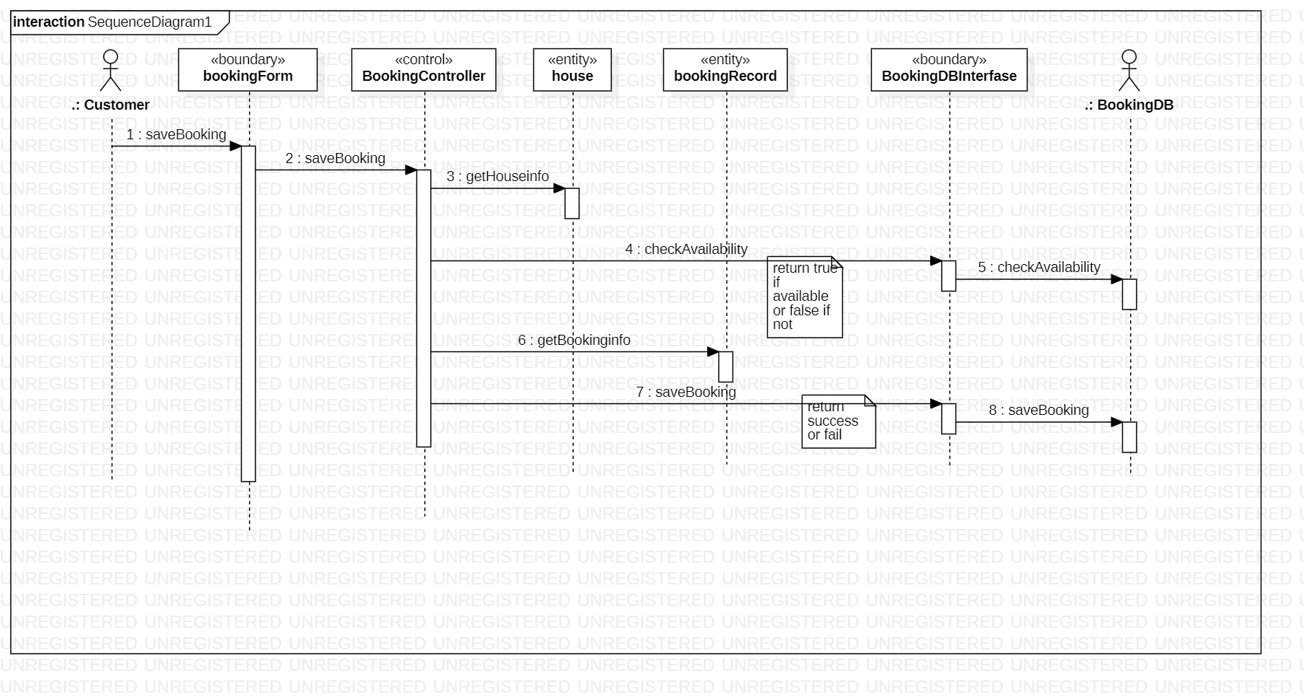

**1.2 Collaboration diagram**

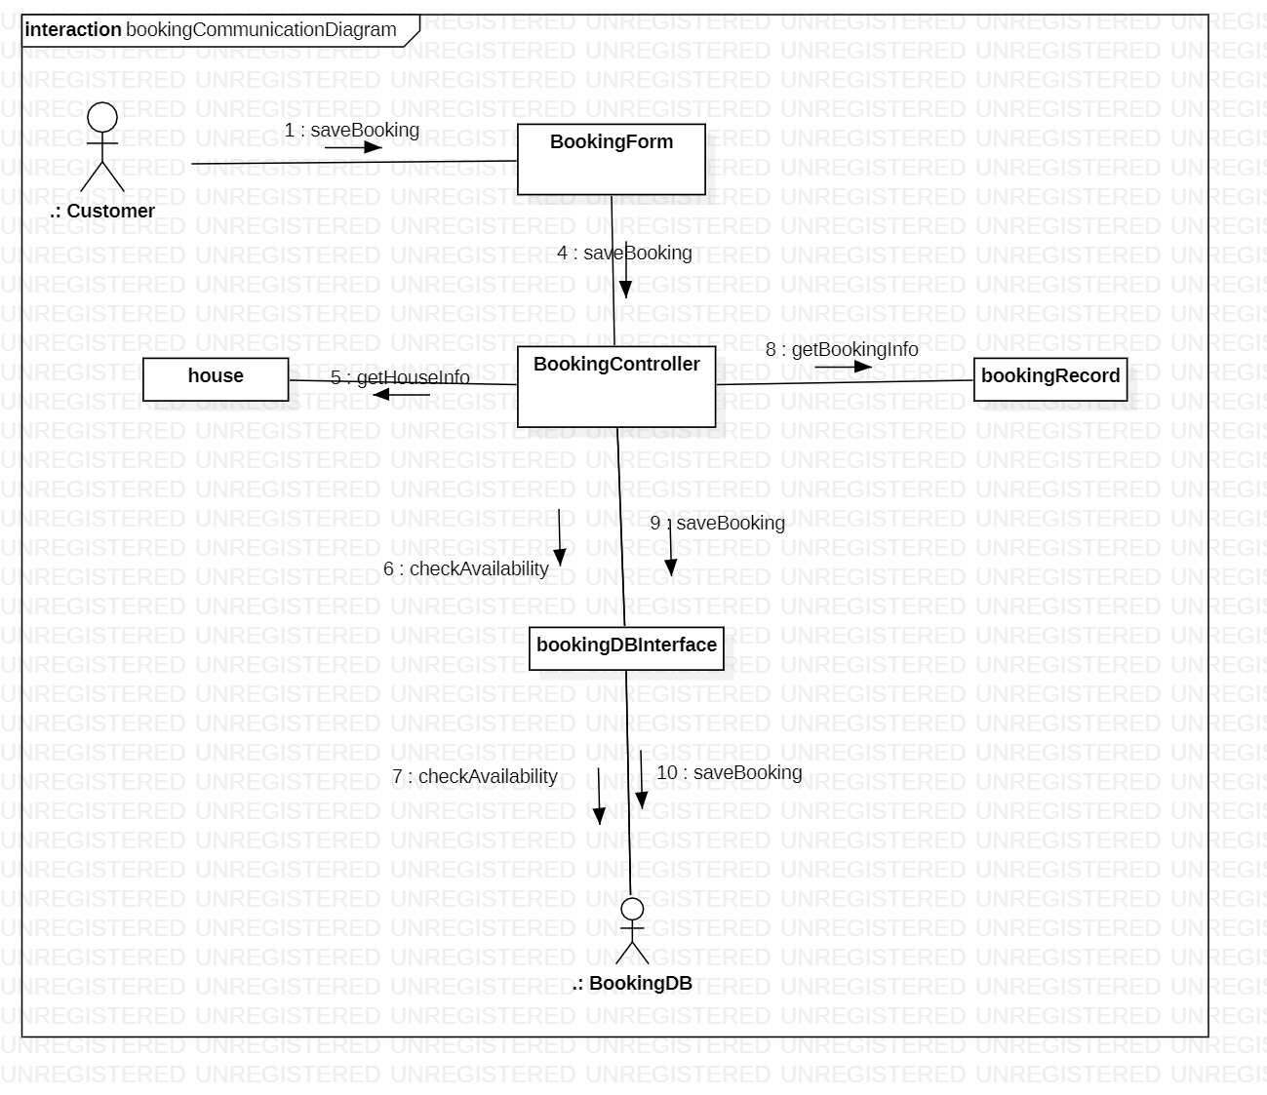

**1.3 VOPC for booking house**

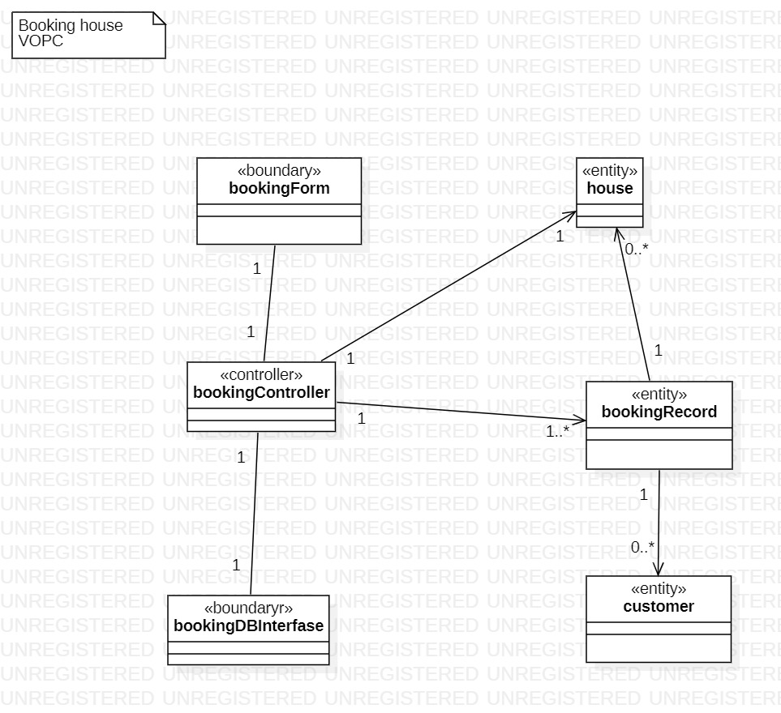

1. Posting a house

2.1 Sequence Diagram

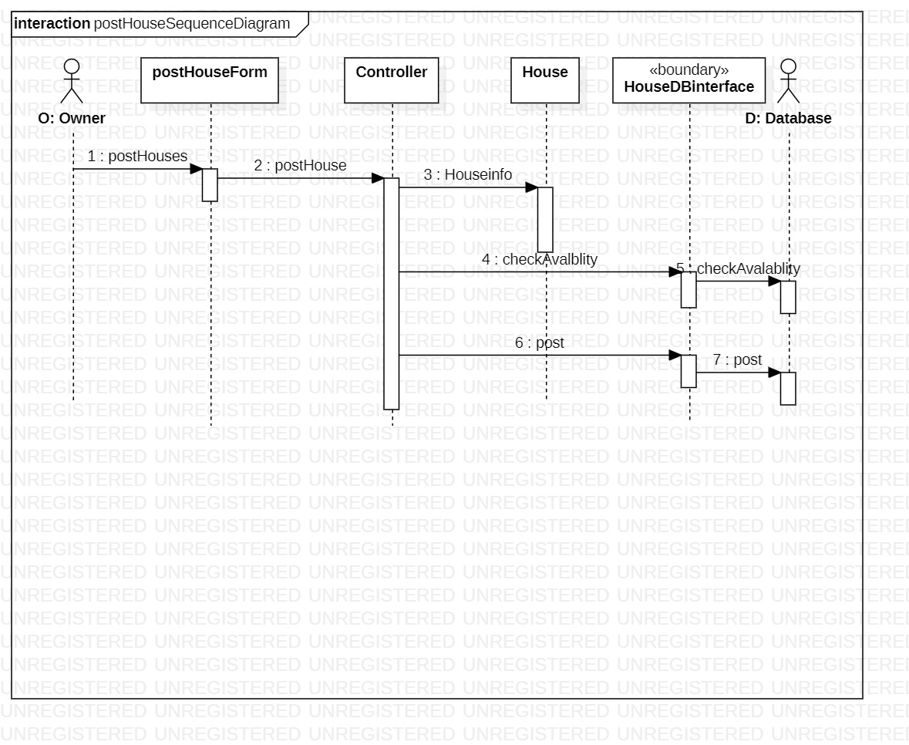

2.2 Collaboration diagram

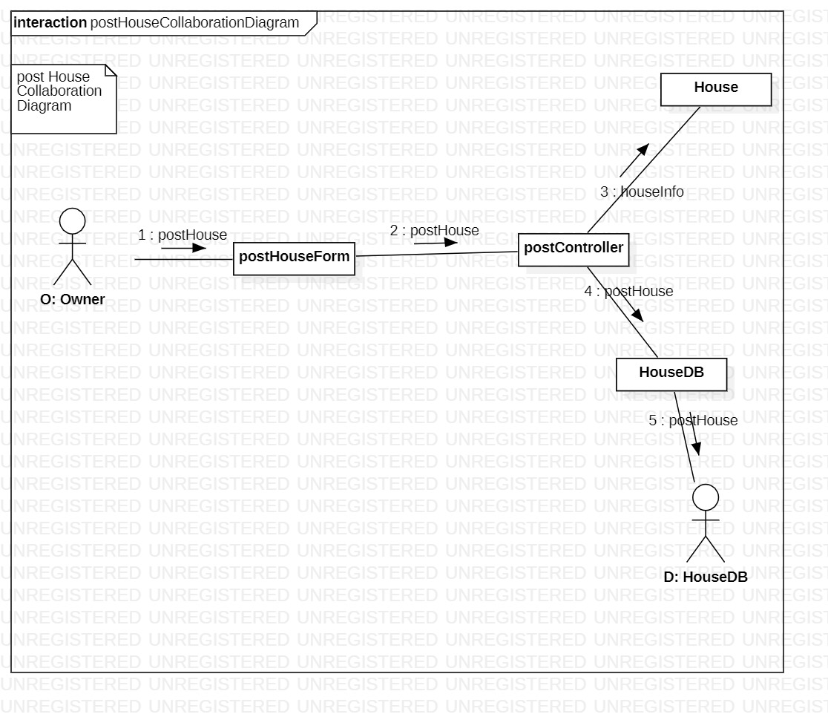

**2.3 VOPC for posting a new house**

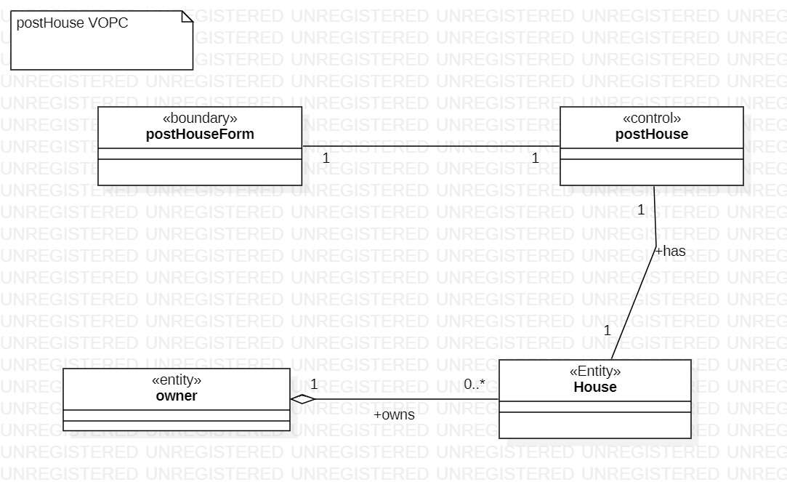

1. Edit house
   1. Sequence diagram

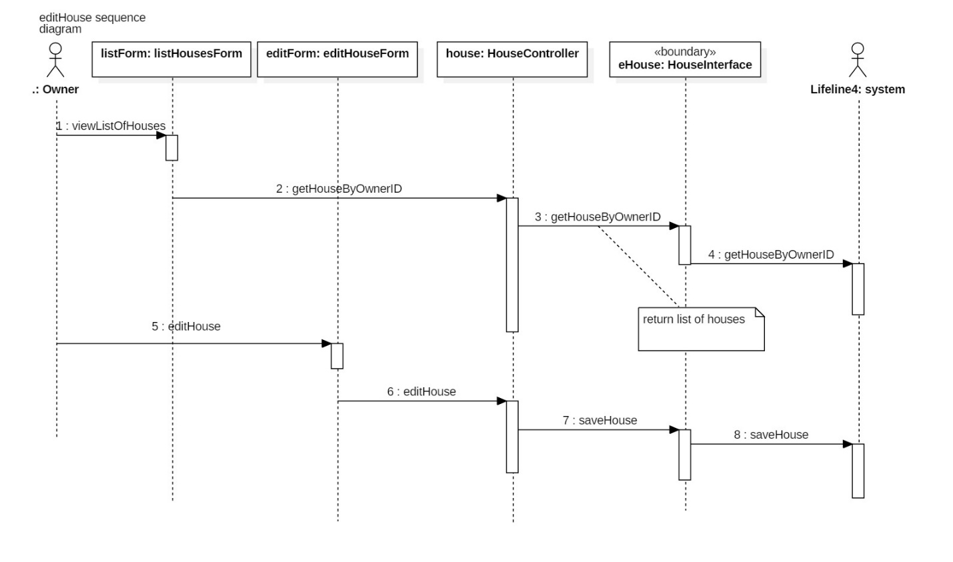

* 1. Collaboration diagram

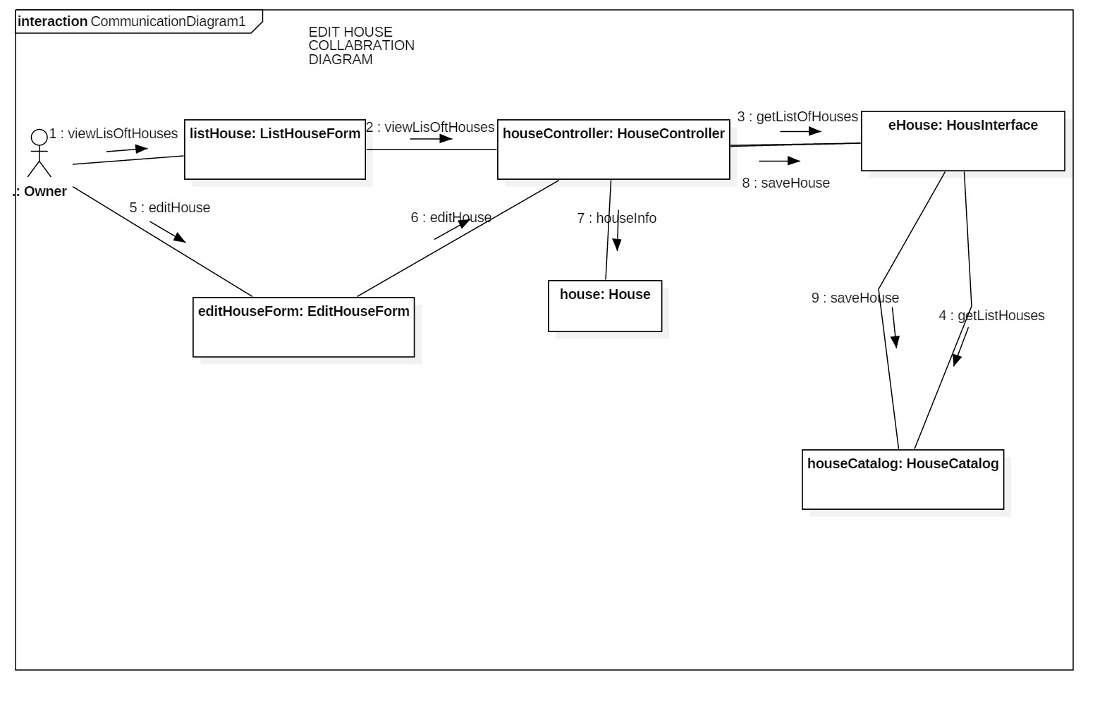

* 1. VOPC

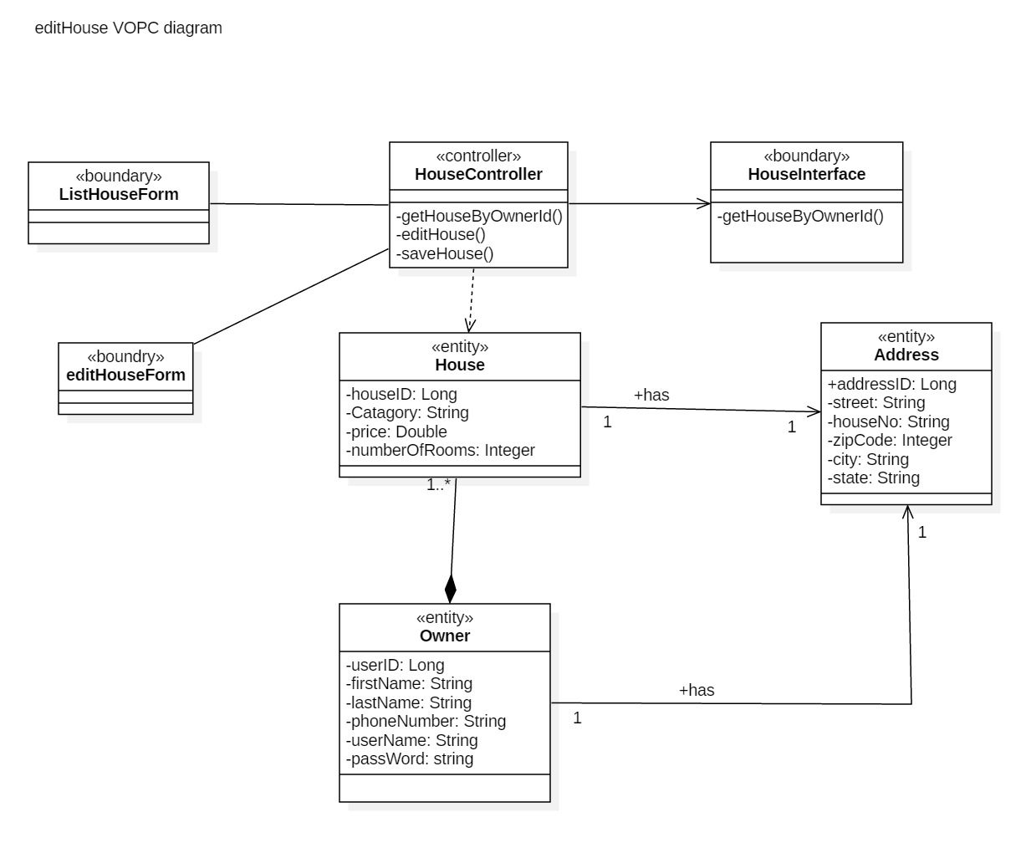

1. Search House
   1. Sequence diagram

* 1. collaboration diagram

* 1. VOPC

